Intake and Exhaust Manifold Design: Part 1
John Kerr

Intake Manifold
Intake Manifold – Directs air flow into the cylinder head

Throttle Body – Controls the air flow into the intake manifold

Intake Manifold Plenum – Most of the volume of the intake manifold, where the cylinder draws its air from.

Intake Manifold Runner – Connects the plenum to the cylinder head

Ram Air Theory – Tuned runner lengths which can give you a boost of air flow into the cylinder.

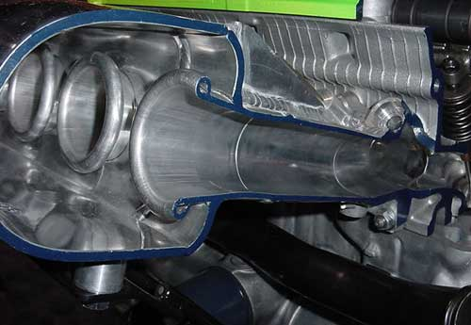

Turbo Manifold
Usually made of 304 stainless steel to help resist cracking.

Utilize a waste gate priority design to help control the amount of exhaust gases that enter the turbine housing, this prevents over-boosting and causing damage to the motor.

Fluid bends and a manifold with optimal volume will help promote more top end power.

In general the shorter/less material the turbo manifold has the faster the turbo will spool up. The longer/more material the manifold has the slower it will spool, but generally will create more top end horsepower.
